COMMUNICATION CIRCUIT DESIGN – LAB 2

**Problem Statement:**

**Aim:** Design a two op-amp narrow-band, RC notch filter with a center notch frequency, ƒN of 1kHz and a -3dB bandwidth of 100 Hz. Use 0.1uF capacitors in your design and calculate the expected notch depth in decibels. Plot the frequency response using Multisim software.

**Software Used:** Multisim v14.2

**Theory:**

A Notch filter is nothing but a narrow band-stop filter. If the stopband of band-stop filter is very narrow and highly attenuated over a few hertz, then that special type of band-stop filter is known as Notch filter. Since the stop band of Notch filter is narrow upto few Hz so the Notch filter is also known as Narrow band stop filter in some cases. It is a highly selective (High Q value) form of band-stop filter which can be used to block a single or very small band of frequencies rather than whole bandwidth of different frequencies.

It acts as a gain for one frequency component and attenuator for all other frequencies.Notch filter by design has a very narrow stop band around their center frequency. The width of the notch is being calculated by its selectivity Q in exactly the same way as the resonance frequency peak is calculated in the RLC circuit.

**Notch Filter Frequency Response**

The ideal response of any notch filter would be a completely flat response over the usable range with the exception of notch frequency as shown in the figure below.

[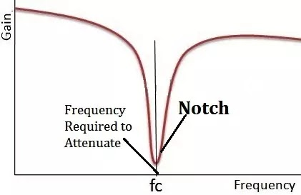](https://1.bp.blogspot.com/-gcKuWjZO3O0/XlWCP3LsaoI/AAAAAAAAAgo/qqzGrhpXN-EbUxOnBxGxv72QVfCy-VwpACLcBGAsYHQ/s1600/Notch+Filter+Frequency+Response.webp)

Practically perfection is very tuff to achieve. But by using the operational amplifier circuit, a high level of attenuation and narrow notch can be achieved.

**Notch Filter Circuit**

The most common Notch filter design is the twin-T notch filter network. In its basic form, the twin-T also called a parallel-T configuration. It consists of two RC branches in the form of two tee sections connected in parallel.

The basic twin-T Notch filter circuit is shown in the figure below as:

[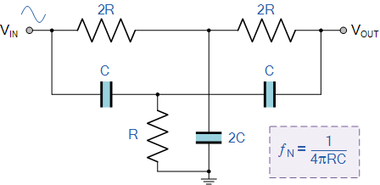](https://2.bp.blogspot.com/-Q7K8YJhIIvA/XOQ6U5YZPSI/AAAAAAAAAL4/WA0wYK30gtIUllMoHemvuGX8SlY3xaIigCLcBGAs/s1600/basic+Twin-T+Notch+filter+circuit.gif)

The upper T-configuration of resistor 2R and capacitor 2C form the low pass filter section, whereas the lower T-configuration of resistor R and capacitor C form the high pass filter section of the design.

The frequency at which this basic twin-T notch filter design offers maximum attenuation is called **Notch frequency**. So, notch frequency is formulated as:

[notch frequency](https://3.bp.blogspot.com/--gwISm3AvJA/XOQ64ufQoWI/AAAAAAAAAMA/3jGEBQ_xY8Y6IlXsiXOOicb-xqwN3N4ewCLcBGAs/s1600/notch+frequency.gif)

For obtaining a high level of attenuation and narrow notch, an operational amplifier is used to design a single Op-Amp twin-T notch filter circuit. The single Op-Amp twin-T notch filter circuit is shown in the below figure as:

[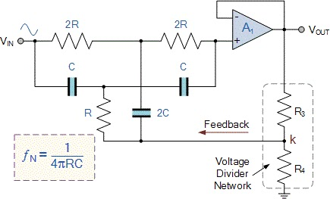](https://1.bp.blogspot.com/--CetLtRnhsc/XlWEYhSoTXI/AAAAAAAAAg0/VIndmpyf3g8wxk2Bi9uX6WuNbeEpvYBGACLcBGAsYHQ/s1600/single+Op-Amp+Twin-T+Notch+filter+circuit.webp)

**Notch Filter Design**

For designing a two Op-Amp narrow band RC notch filter with center notch frequency of 1kHz and 3-dB bandwidth of 100 Hz. Consider the 0.1uF capacitor and calculate all the value of the required components as explained in the below steps.

**Circuit Diagram:**

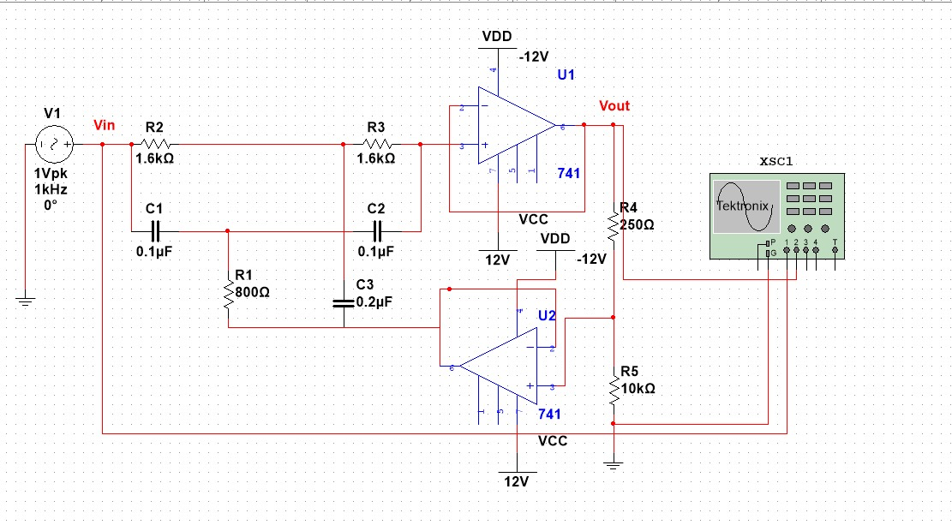

**Frequency Response:**

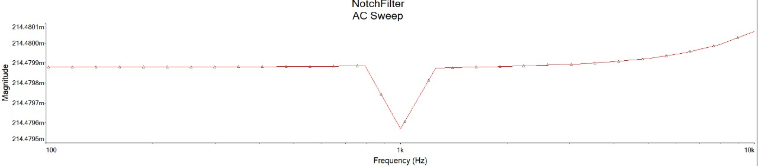

**Calculations:**

***Step 1***: Calculate the value of R for the given capacitance of 0.1uF.

R = $\frac{1}{4πfnC}$ = $\frac{1}{4π\left(1000\right)(0.1)({10}^{-6})}$ = 795Ω ≈ 800Ω

***Step 2***: Calculate the value of Q.

Q = $\frac{fn}{BW}$ = $\frac{1000}{100}$ = 10

***Step 3***: Calculate the value of feedback fraction K.

K = 1 - $\frac{1}{4Q}$ = 1 – 0.025 = 0.975

***Step 4:*** Calculate the value of R3 and R4.

K = $\frac{R3}{R3+R4}$ = 0.975

Assume R4 = 10 kΩ,

R3 = 10000 (1 - 0.975) = 250Ω

***Step 5***: Finally Calculate the value of notch depth in dB as:

fN(in db) = 20.log (1/Q) = 20.log (1/10)

= -20 db

**Conclusion:**

Designed a circuit with two narrow-band op-amps and a RC notch filter. Plotted the frequency response using Multisim software and the notch depth was achieved and calculated in decibels from the designed circuit.